PROJECT REPORT

# Agents of shield- group

SHEEZA WAHEED F2019376032

MUHAMMAD OZAIR ATTIQ F2019376032

Tool Used:

The tool we used for our project is Netlogo -version 6.2.2

Language:

Coding was done in Netlogo language using no libraries

Environment:

The environment or “setup” as said in Netlogo looks like the following:

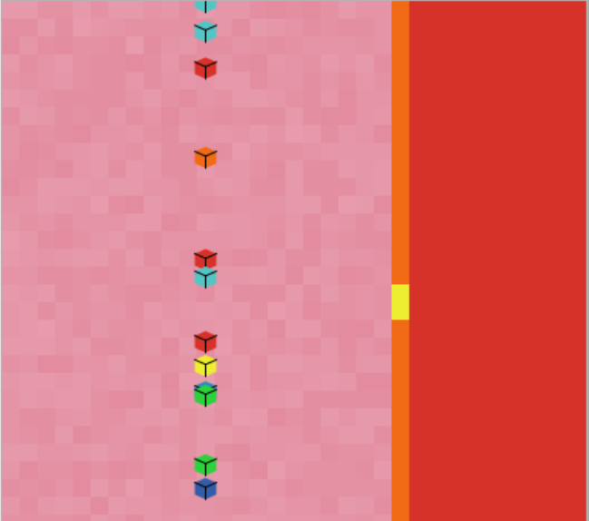

* The pink background or “patches” is where the agents are initially “randomly” placed on the y-axis but fixed x-axis “-5” this is so that all of them get the same distance from the target (the yellow patch through which they have to pass)
* Orange line separating the red patches and pink is the “barrier” which all the agents have to avoid colliding with because it will kill them and declare them as looser
* Red patches are where the winner is placed after it has crossed the yellow patch successfully without colliding with anything (barrier and other agents)

At go:

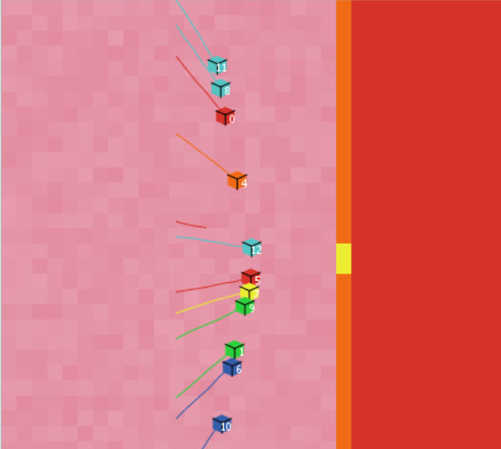

* All the agents start moving towards the patch yellow, setting this as their target, creating a sense of competition
* On the way, if one of the agents is too close in the radius of any other agents it is advised to randomly change its direction
* If even after changing its direction the other agents defect and moves forward it will kill the other agent that cooperates
* As u can see in the screenshot that agent 12 has moved forward while an agent red has died

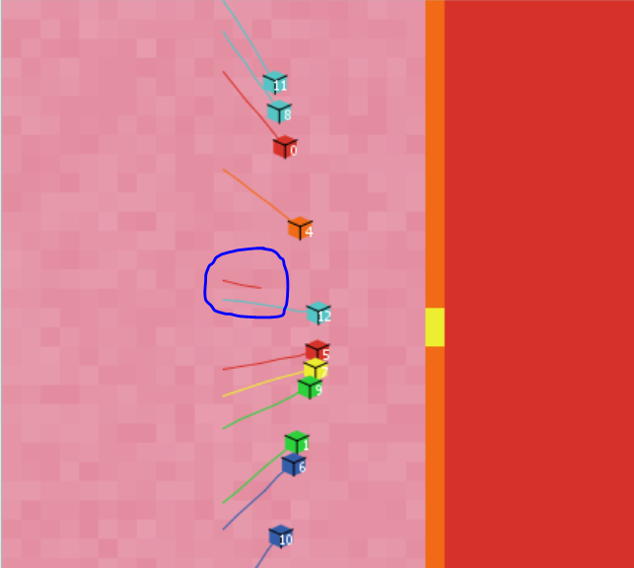

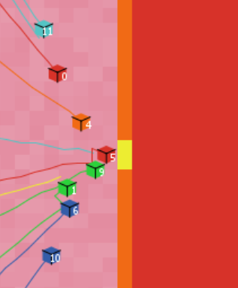

* As seen now the agent 5 changed its direction from agent 9 and has taken the lead

End program:

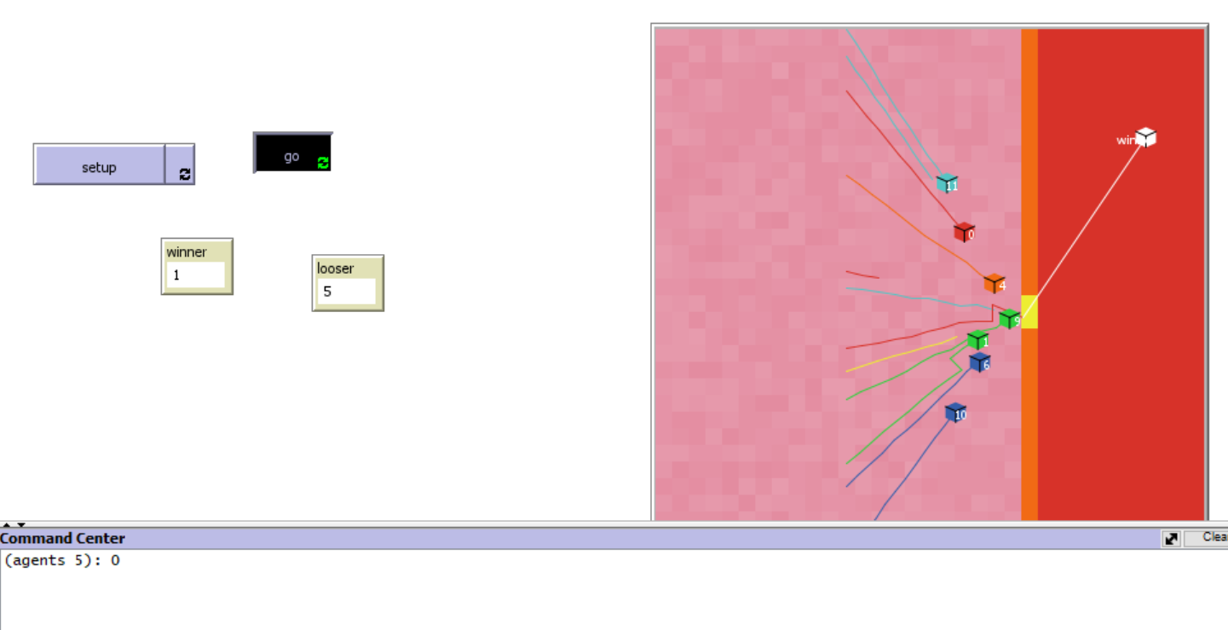

Agent 5 has crossed the yellow patch and reached the red region “the winner’s arena”. Upon wining its color is set to white and labelled as winner gaining the score 0 while everyone else scored -1 and stopped wherever they were.

Looser 5 are the 5 agents who collided and died.

Scores in this game:

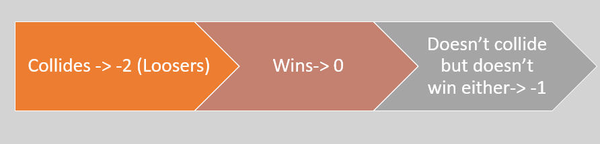

Exceptional case:

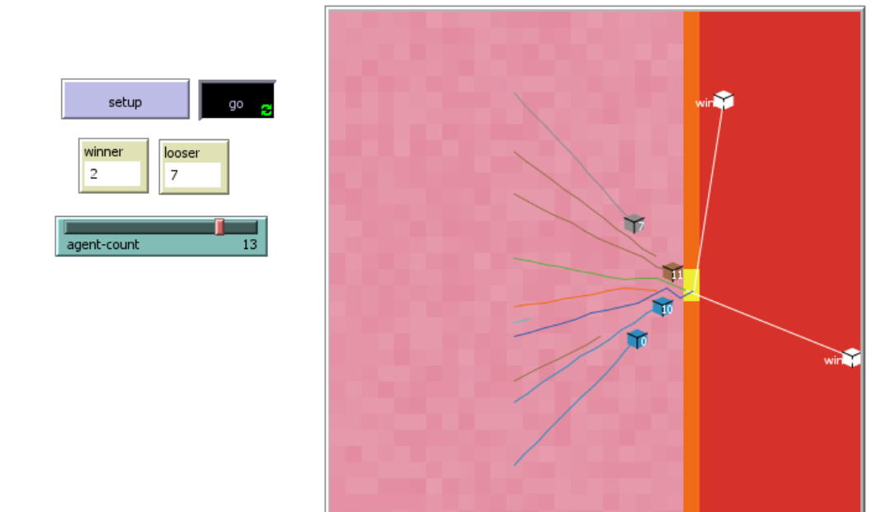

Sometimes there is a tie situation where two agents win because they both entered the yellow patch with the difference of milli second. However, both of them are declared as winners.

Nash equilibrium

It is situation is a situation where no further Improvement to a state of an agent can be done and it was the best action in the given scenario

Pareto optimal

is the optimal outcome of a game where an agent chose the best option for himself and the other agent cannot make a better move.

Can we apply this in our game?

We have seen a situation where two agents are moving together in the same direction and are too close to each other

They have two choices

1. Keep moving forward (defect) => take a lead
2. Change direction a little as to not collide (cooperate)

If agent 1 chose defect and agent 2 chose cooperate because of agent 1, this is pareto optimal for agent 1 however from the perspective of agent 2 this was “Nash equilibrium” because there was no better option than to cooperate. If it chose to defect it would have collided with agent 1

What does it mean when we said agent 2 chose this because of agent 1? There was no communication however Netlogo works on tick system. On each tick there is a movement which influences a change in the environment. Suppose :If on tick 59 agent 1 was still moving in same direction when it was too close to agent 2 , on tick 60 agent 2 will know the intentions of agent 1 and make a move accordingly.

Buttons added:

* Setup button is to set the environment after the program has ended
* Go button is to start the program
* Winner output button is to display the number of winners
* Looser output button is to display the number of looser (who collided)
* An agent count slider is to set number of agents on the field from minimum 5 to max 15
* A command prompt at the bottom displays which agents has won and gained “0”

## End of report